**Final Output:**

The following screenshots depict the deployment of the model on a Public IP (**http://13.201.84.142/)**utilizing an AWS EC2 Ubuntu virtual machine instance with Nginx.

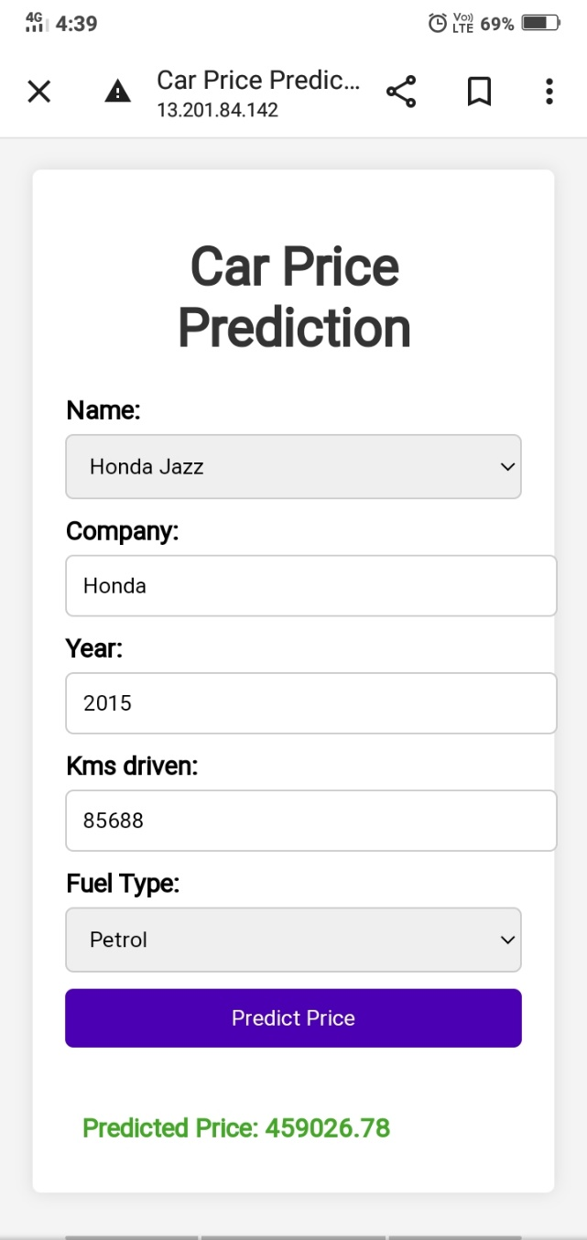 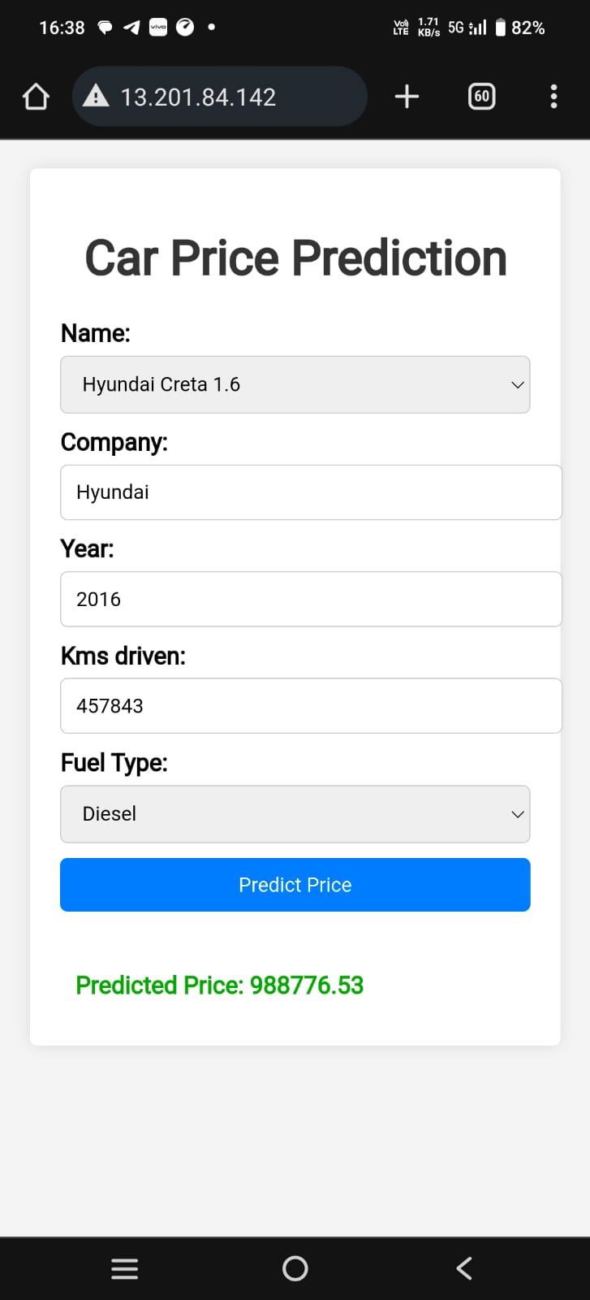

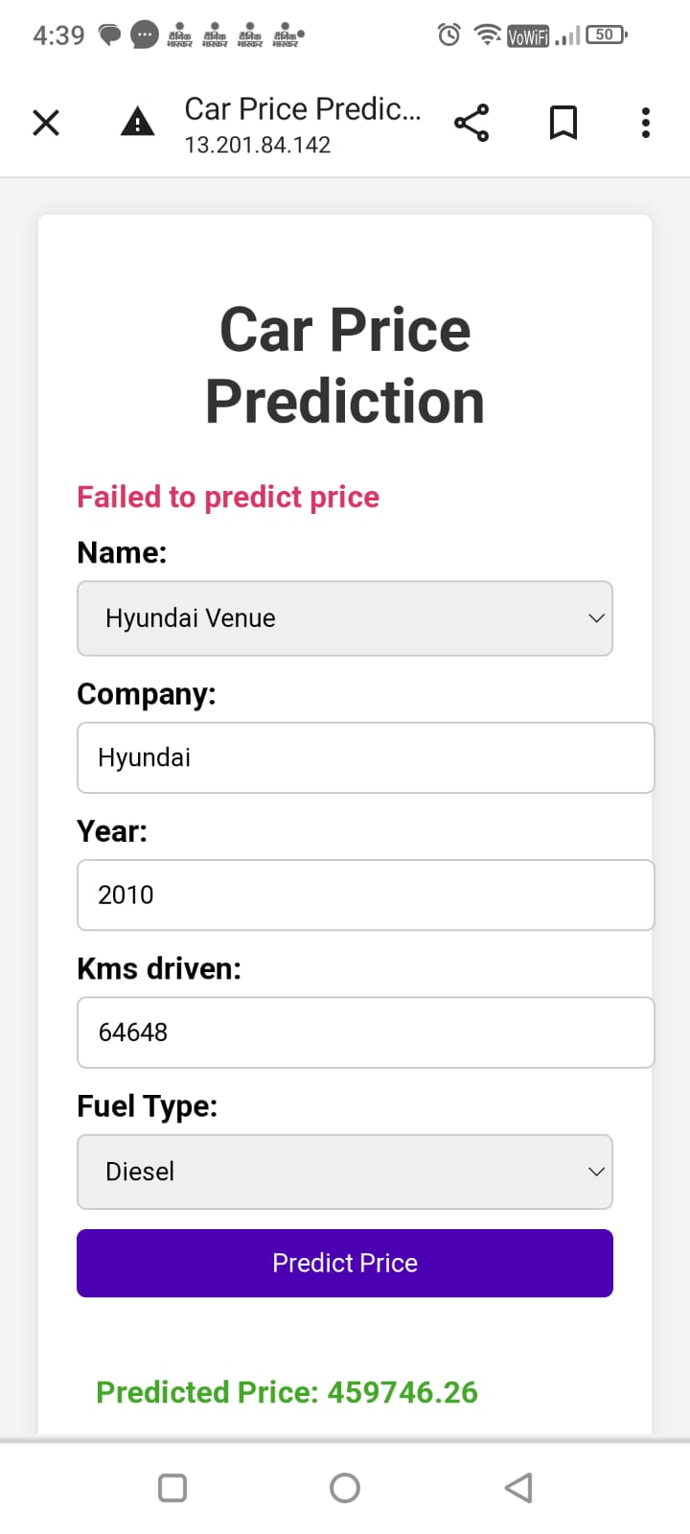Case: - In case the user fails to fill any of the columns it will give you an error “Failed to predict price”.  
Just after the user filled the remaining it will give you a “Predicted Price”.

This deployment showcases the seamless integration of our model within a robust infrastructure, ensuring accessibility and scalability for our users.